Gedling Borough Council Designation of an Area for Selective Licensing Phase 2, Carlton Hill, Colwick, Daybrook, Newstead Village 2022.
Gedling Borough Council in exercise of their powers under section 80 of the Housing Act 2004 (“the Act”) hereby designates for selective licensing the area described in paragraph 4.
CITATION, COMMENCEMENT AND DURATION
1. This designation may be cited as Gedling Borough Council Designation for an Area for Selective Licensing – Phase 2, Carlton Hill, Colwick, Daybrook, Newstead Village 2022.
2. This designation is made on 6th July 2022 and shall come into force on 1st November 2022
3. This designation shall cease to have effect on 30th October 2027 or earlier if the Council revokes the scheme under section 84 of the Act.
AREA TO WHICH THE DESIGNATION APPLIES
4. This designation shall apply to the residential area of Carlton Hill, Colwick, Daybrook and Newstead Village as delineated and edged red on the map at annexes A,B,C and D.
APPLICATION OF THE DESIGNATION
5. This designation applies to any house as defined by the Act which is let or occupied under a tenancy or licence within the area described in paragraph 4 unless-
(a) the house is a house in multiple occupation and is required to be licensed under Part 2 of the Act;
(b) the tenancy or licence of the house has been granted by a registered social landlord;
(c) the house is subject to an Interim or Final Management Order under Part 4 of the Act;
(d) the house is subject to a temporary exemption under section 86 of the Act; or
(e) the house is occupied under a tenancy or licence which is exempt under the Act or the occupation is of a building or part of a building so exempt as defined in annex b;
EFFECT OF THE DESIGNATION
6. Subject to sub paragraphs 5(a) to (e) every house in the area specified in paragraph 4 that is occupied under a tenancy or licence shall be required to be licensed under section 85 of the Act.
7. Gedling Borough Council will comply with the notification requirements contained in section 83 of the Act and shall maintain a register of all houses registered under this designation, as required under section 232 of the Act.
Date and authentication by the Council. 6th July 2022

Annex A – Designated area for Selective Licensing – Carlton Hill 2022
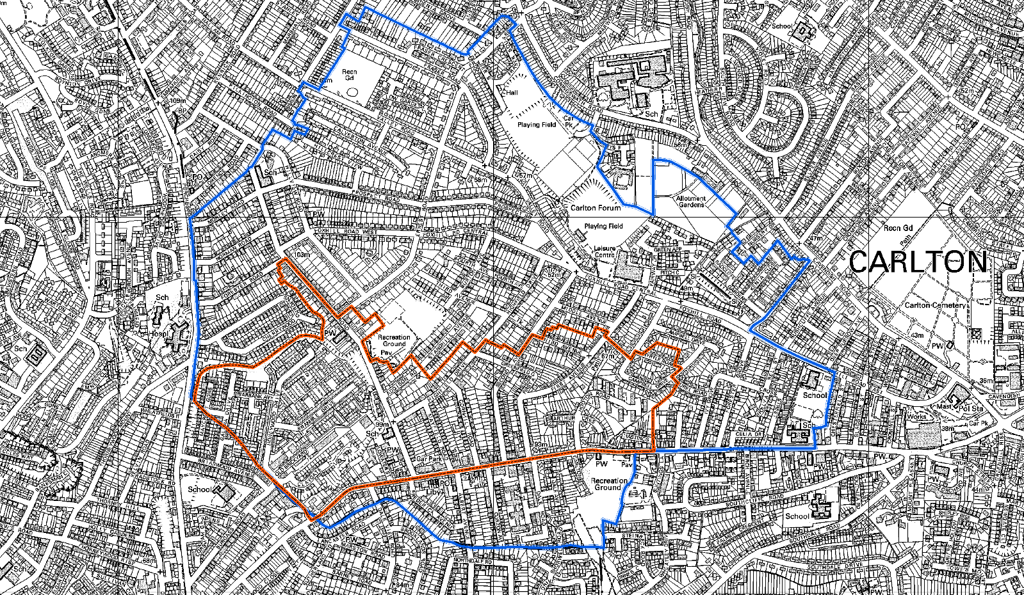

Annex B – Designated area for Selective Licensing – Colwick 2022
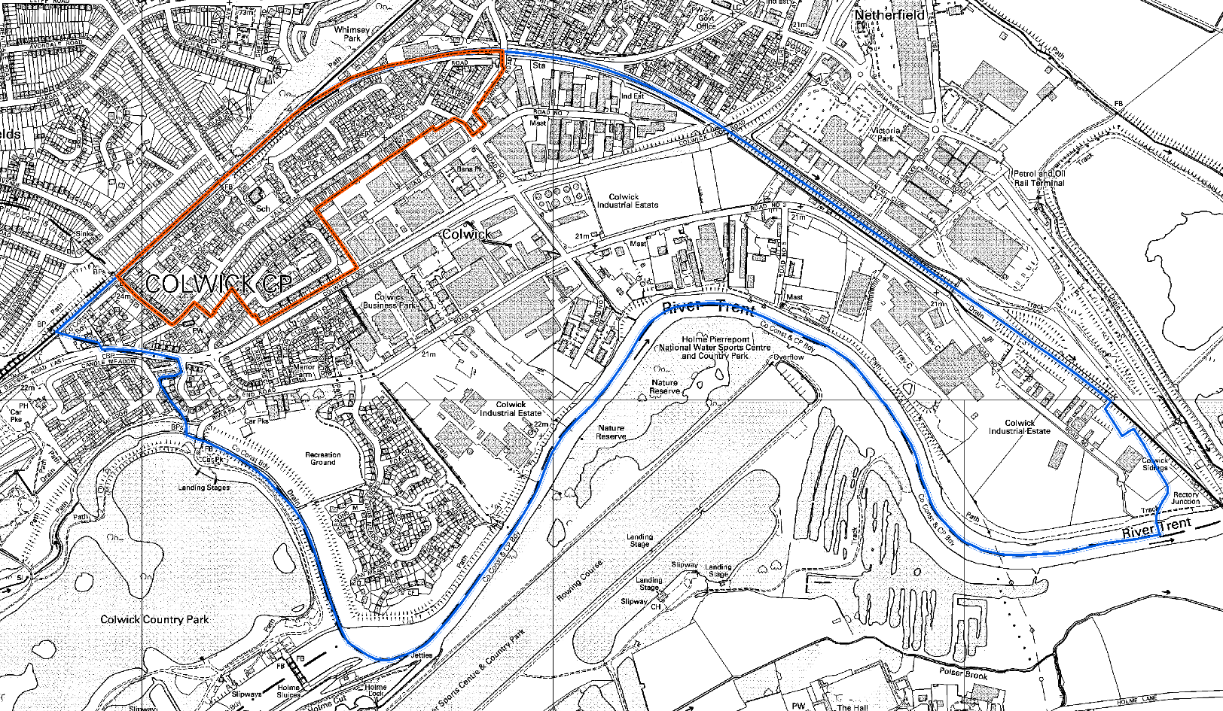

Annex C – Designated area for Selective Licensing – Daybrook 2022
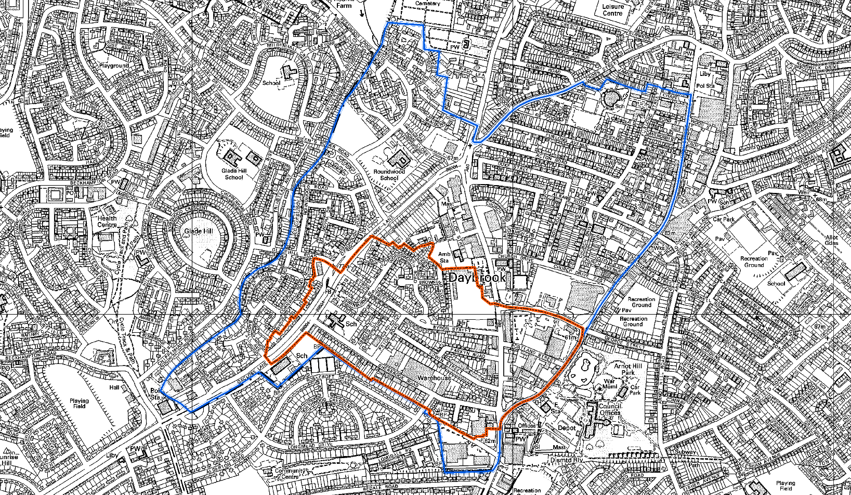

Annex D – Designated area for Selective Licensing – Newstead Village 2022
